Spring boot Rest full Web Service

In Spring boot we need to add web starter and in place @Controller

We need to write @RestController annotation.

When we write @Restcontroller annotation we can write return type of method string or user defined object with produce attribute.

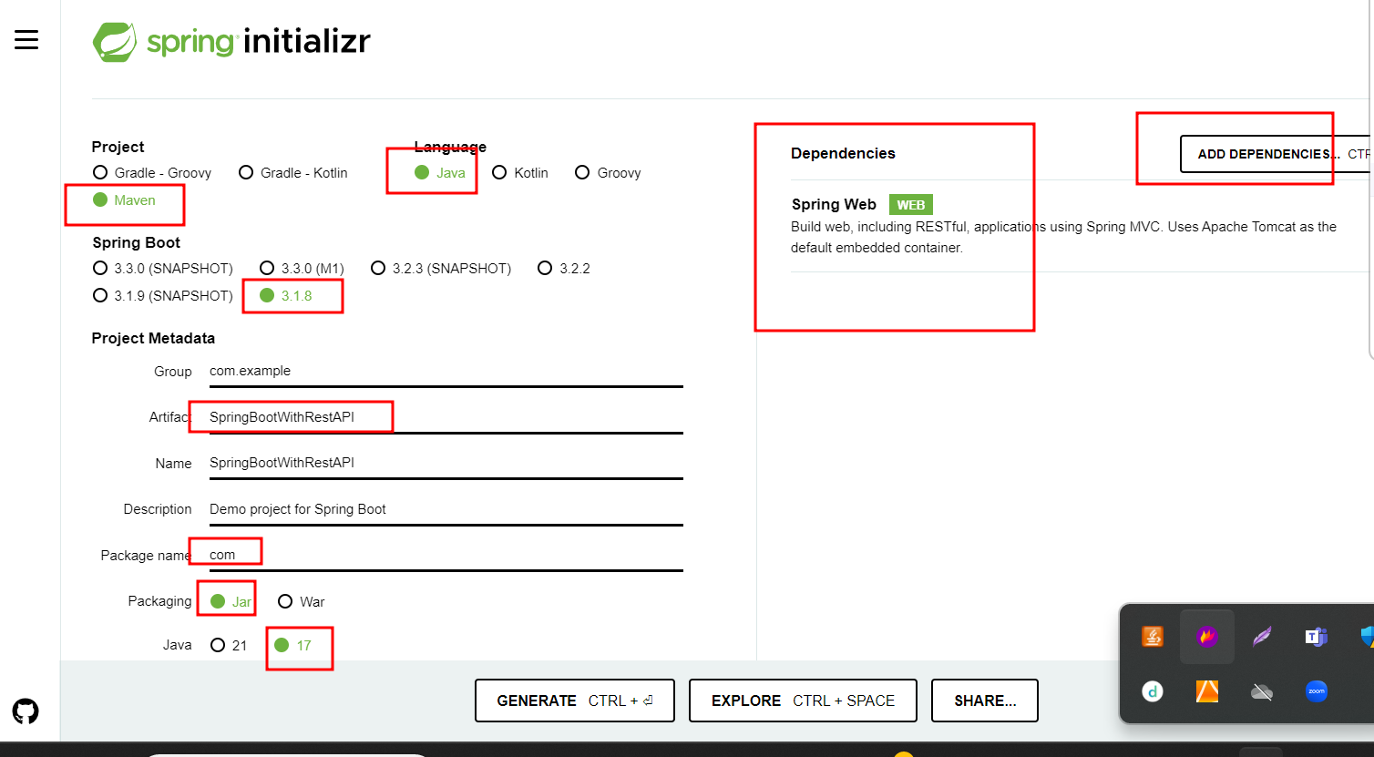

@Controller annotation is use to return view as jsp or thymeleaf

@Restcontroller annotation is use to return rest api.

Before @Restcontroller we if want to use rest api concept

@Restcontroller = @Controller + @ResponseBody;

Spring boot with Rest API interacting with database using Spring JPA Data.

Entity can be Employee, Customer, Manager, Product, order etc.

ProductManagementRestAPI -🡪 project name

Web starter -🡪 to create web service

Jpa starter --🡪 to use core jpa or spring jpa data.

Mysql connector -🡪 to connect mysql database

Dev starter -🡪 it is use to refresh the project whenever we do any changes.

(only in development mode).

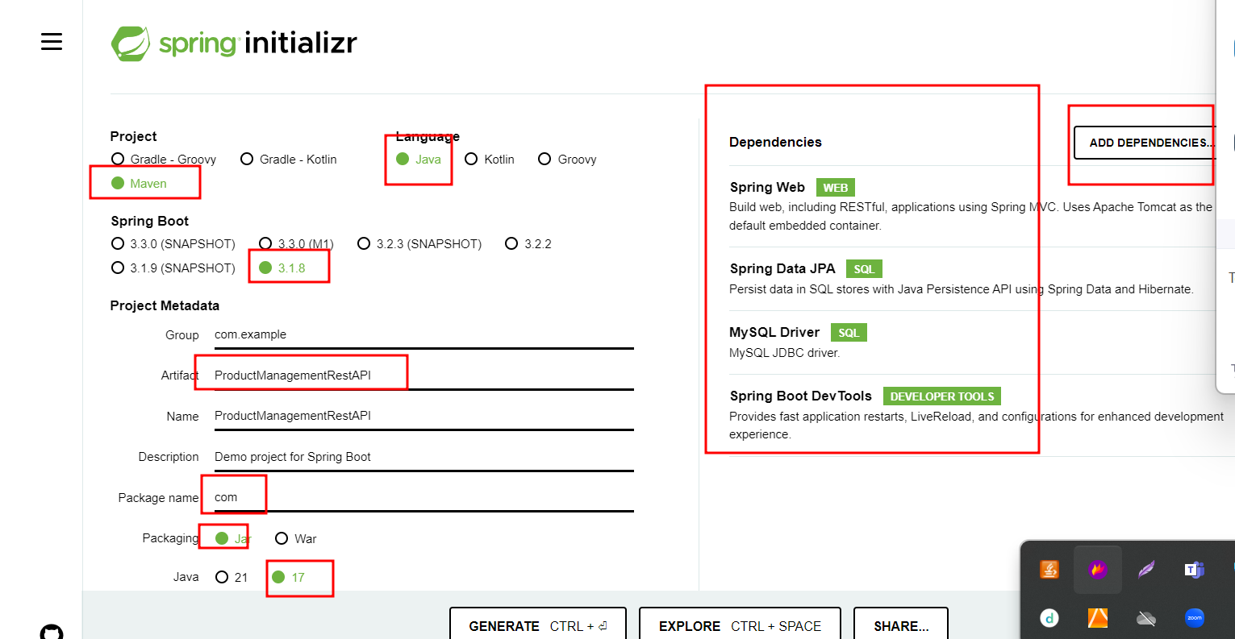

Spring JPA Data.

JPA Data provided two interface ie CrudRepository and JpaRepository.

These interface base upon java 8 features. Which provided implementation of dao layer.

Java 8 onward interface can contains method with body.

CrudRepository -🡪 Basic Repository

JpaRepository 🡪 Jpa specific repository

JpaRepository interface extends CrudRepository.

We need to create normal interface and that implements may be extends CrudRepository or JpaRepository.

Which takes generic type. 1 class name and 2nd data type of primary key.